Lesson 5 Demo 12: Increase Number of Replicas

This section will guide you to:

* Increase the number of replicas of a task for any given service

**Step 1:** List the Docker services

*sudo docker service ls*

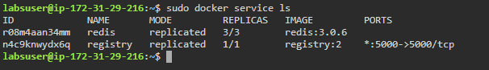

**Step 2:** Scale up the *redis* service to five tasks

*sudo docker service scale redis=5*

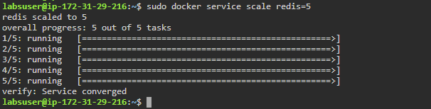

**Step 3:** Scale the *registry* service to four tasks using **update**flag

*sudo docker service update --replicas=4 registry*

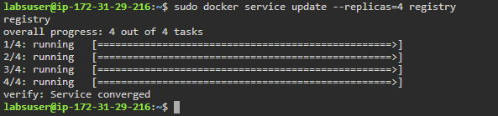

**Step 4:** Use the **scale** flag to scale both *redis* and *registry* services at the same time

*sudo docker service scale redis=4 registry=3*

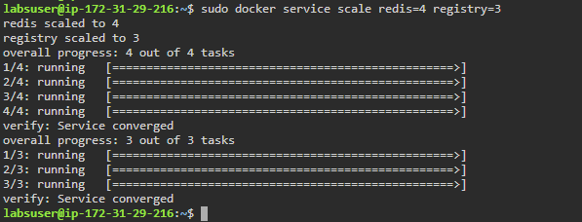

**Step 5:** Check the actual number of replicas created

*sudo docker service ls*

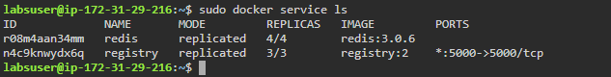

**Step 6:** Create a global service and scale it up to ten tasks

*sudo docker service create --mode global --name nginx nginx:latest*

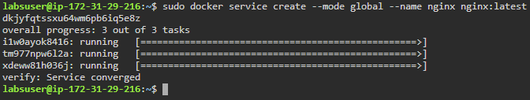

*sudo docker service scale nginx=10*



**Note:** Notice that the scaling cannot be used with global services. It can only be done with replicated service.